MSTS Generic EMD-F59 Cab
By
Charlie Sibaja
(charliesibajamsts@yahoo.com)

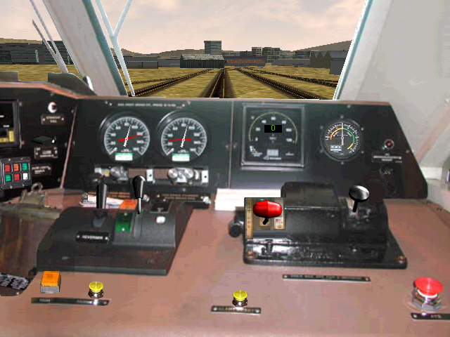

First: You might want to print this document.

Original Read me instructions by Dwight Mitchell.

INTRODUCTION
This is a photorealistic cab for the EMD Engine F59PHI and MPI MP36PH. Has a wide vision angle for a better realistic experience like the real life.

Controls originally by MLT (Freeware KHP route Demo) (www.mapleleaftracks.com).
Left view photo by Paul Duda.

INSTALLATION

- First and most important BACKUP and I do mean BACKUP the entire folder of the engine that you want to use this cab in. If you don’t do this first SHAME ON YOU!!

2. Unzip this file to the drive where MSTS is located (normally drive C:). This will create the directory
x:\Program Files\Microsoft Games\Train Simulator\TRAINS\TRAINSET\Common.Cab\ EMD-F59-CAB

where “x:\” is the drive where MSTS is located.

- In the sub-folder “Cabview” of this file are one cvf files

EMD-F59.cvf---------------Normal F59PHI and cab.

- Choose one of the files in step 3 and copy it into the cabview folder of the engine you want to use this cabview in. You have the option of deleting all other files in this folder if you wish. If your engine does not have a Cabview folder then create one and then copy the file(s) into this folder.

- Open up the *.eng file with an ASCII text editor such as Notepad or Context. Look for the following line (Highlighted this in blue)

NumWheels ( 1 )
MaxTemperature ( 120 )
MaxOilPressure ( 90 )
CabView ( gp38.cvf )
MaxDieselLevel ( 3600gal )
DieselUsedPerHourAtMaxPower ( 60gal )
DieselUsedPerHourAtIdle ( 10gal )

Replace the wording gp38.cvf with the name of the file you used in step 3 (EMD-F59.cvf)

NOTE: Your CabView line might be some other engine other than gp38.cvf.

- Since this cab uses the combined control stand Look for the following lines:

Brake_Dynamic ( 0 1 0.025 0
NumNotches ( 1
Notch ( 0 1 Dummy
)
)
Combined_Control ( 0 1 0.5 0.5 throttle dynamic )
DirControl ( -1 0 1 1 )
BellToggle( 0 1 0 )
AWS ( 0 1 0 )

Add the line highlighted in BLUE

SAVE THIS FILE!

- You might want to run an “Engine Check” first before using. ConBuilder and RouteRiter are good choices’

- If you followed these steps then the engine should work with this new cab. If not you should delete the engine and restore it with the backup you hopefully did.

The real cab.

